FIELD REPORT
Introduction
Place: Aleka Seed Secondary School
Location: Aleka, Oyam district
Date of visit: 24th August 2026
- General observations
- The school has not yet been commissioned (not in operation), and there was no designated school representative available who could provide comprehensive information on the assets either supplied and received or to be received under UgIFT.
- The DEO assigned the inventory officer to support the verification exercise; however, the officer was unavailable because he was engaged in distributing medicines to HC IIIs within the district. In the absence of the inventory officer, the askari provided access to the relevant rooms, enabling the physical inspection of the assets available and accessible on site.
Special notes
- All assets are not engraved
- The absence of the inventory officer limited access to information on the quantities, specifications, and documentation of the assets.
- The physical assets observed could therefore be confirmed as present on the ground, but their UgIFT attribution could not be fully established during the visit. Clarification is also required on the source and program attribution of the school infrastructure.
Below are photos of some of the items stored at the school premises and the buildings

The table below illustrates some physical status of the verified assets with photographic evidence.
Table XXX: Physical verification photos
DESKTOP MONITORS | 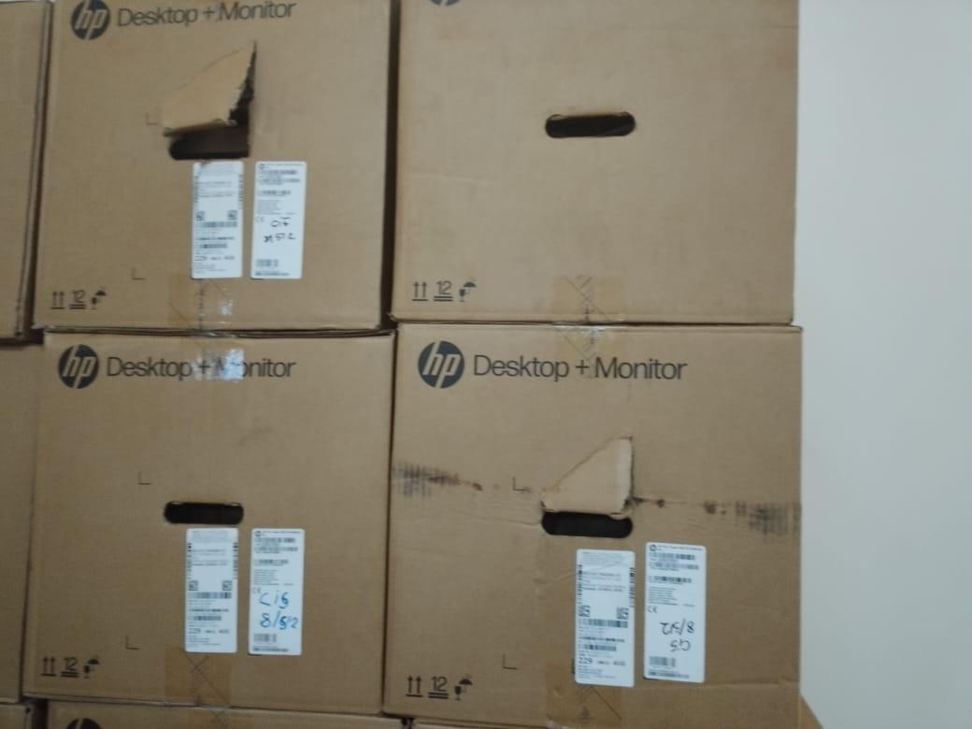
SERVERS | 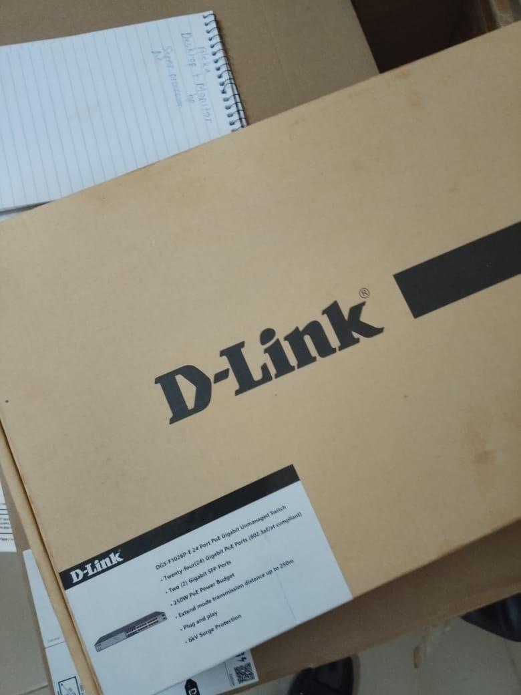
ROUTER | 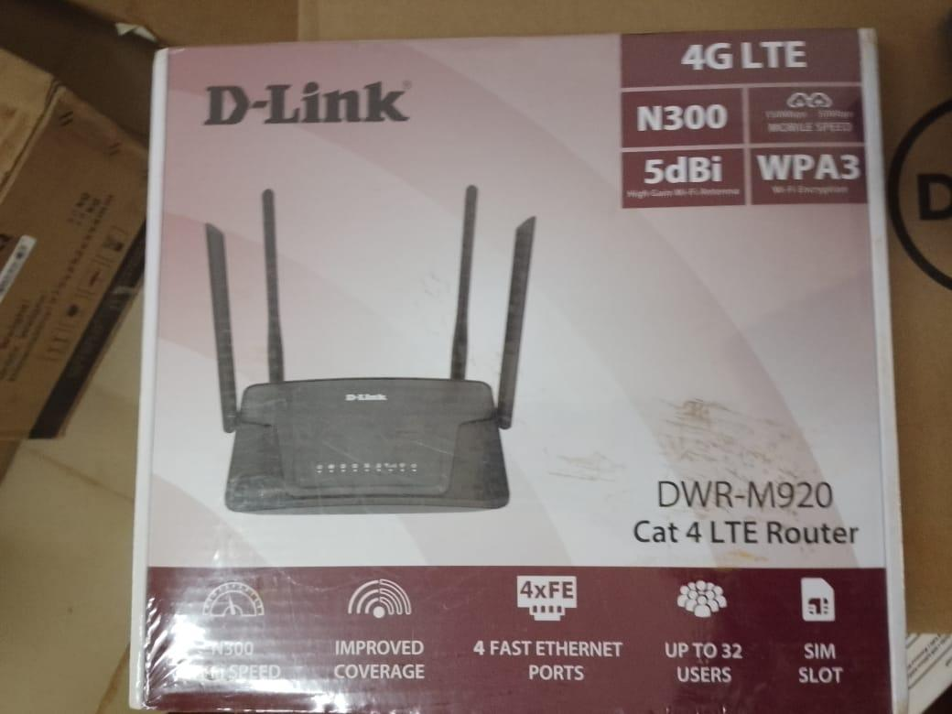
AIR CONDITIONER | 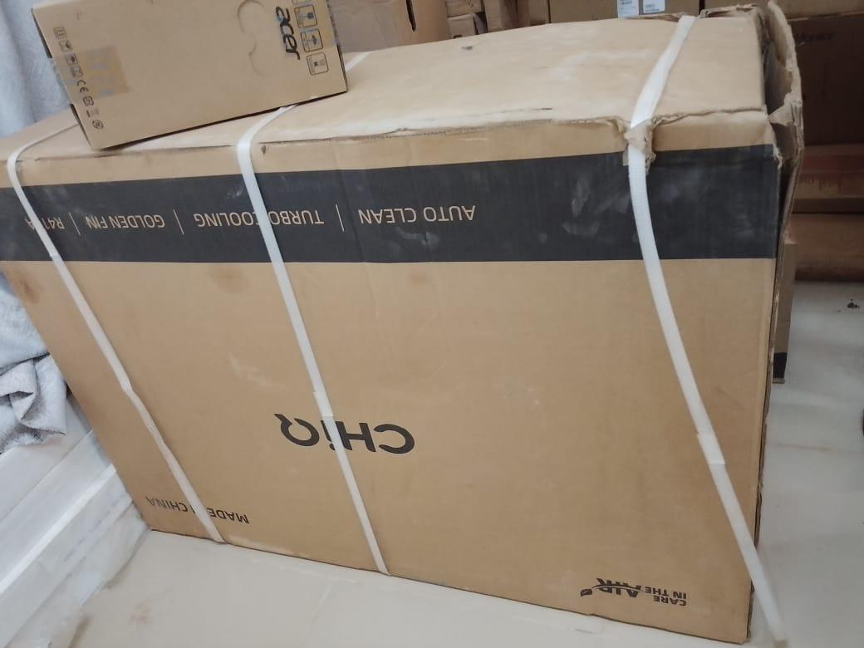
POWER SURGE PROTECTORS | 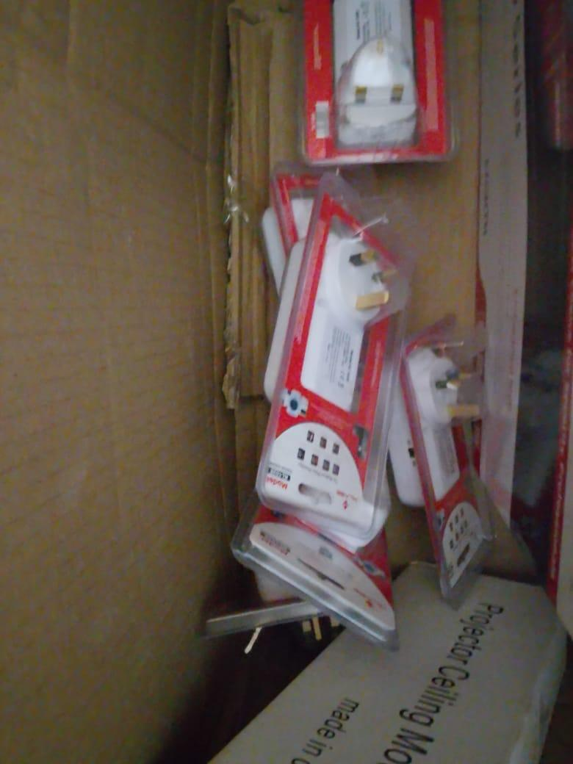
COMMUNICATIONS CABLE | 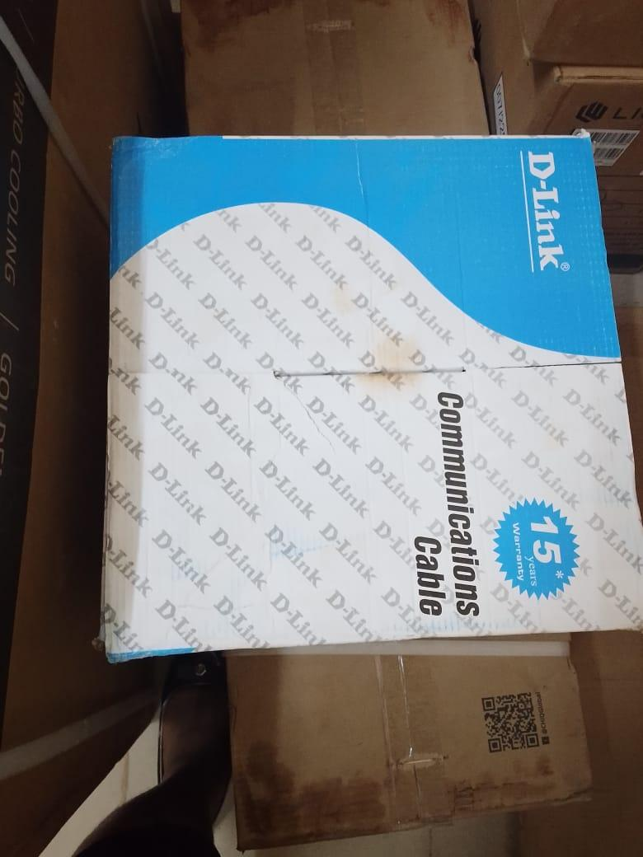
CCTV CAMERA | 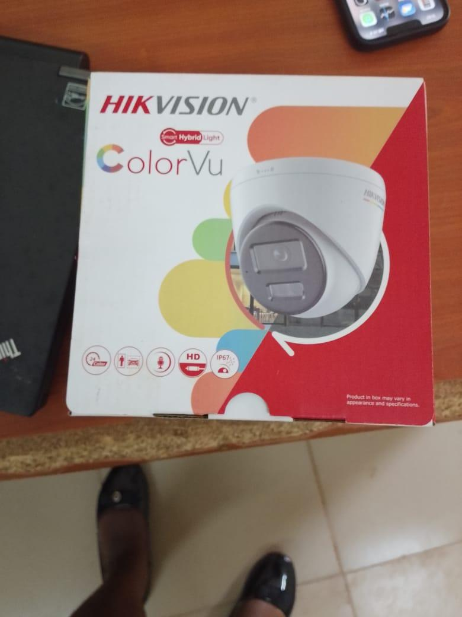
ADMINISTRATION BLOCK | 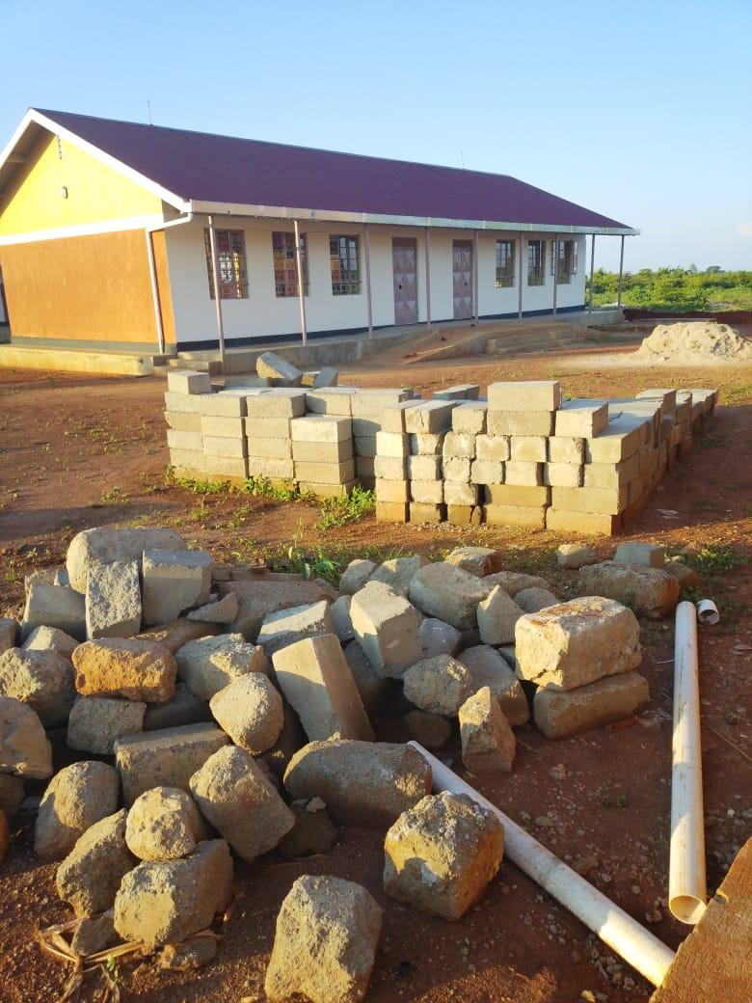
CLASSROOM BLOCK | 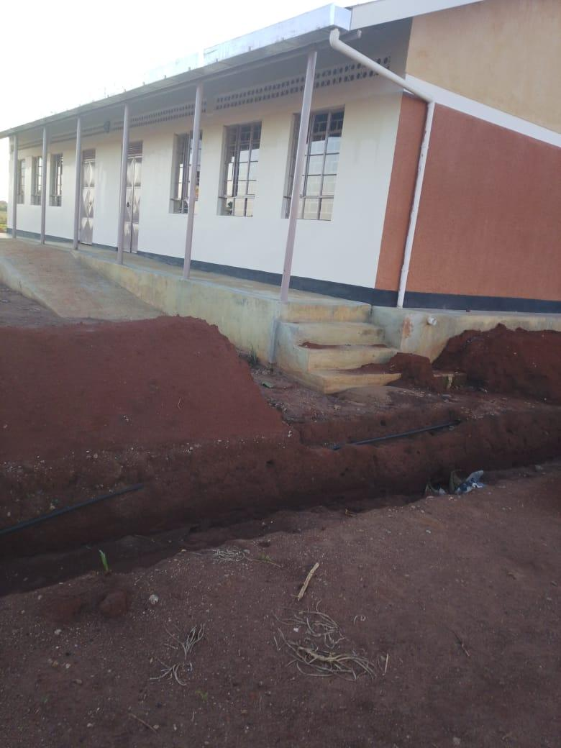
ICT/LIBRARY BLOCK | 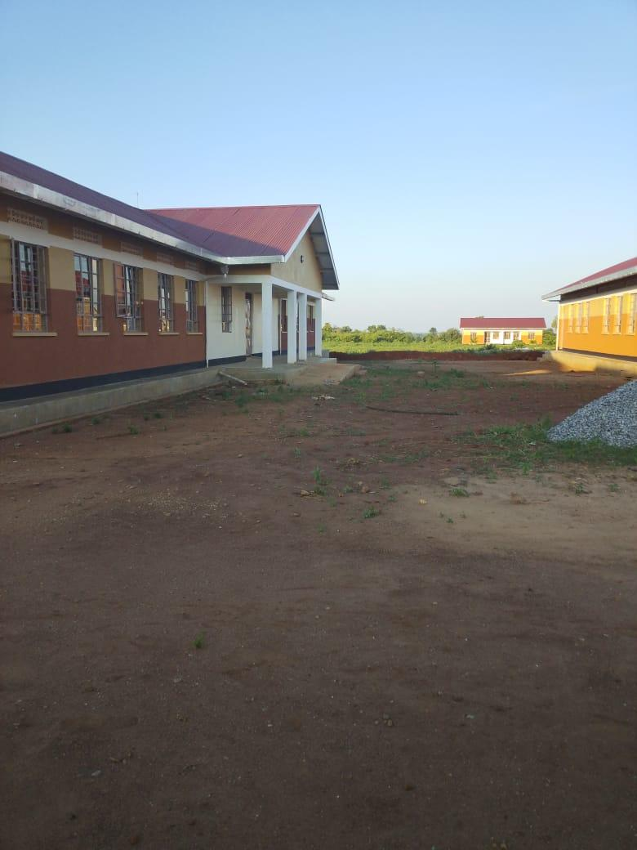
LAB STOOLS | 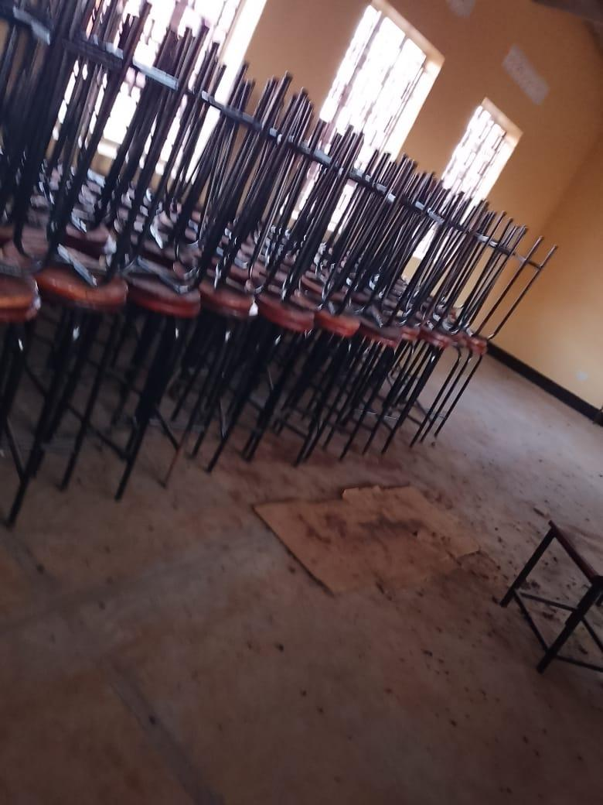
CHAIRS | 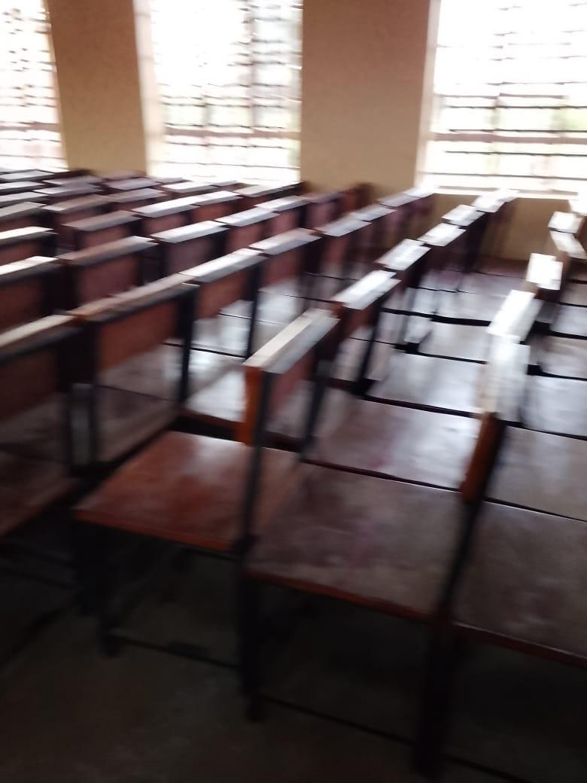
SHELVES IN THE MAKING | 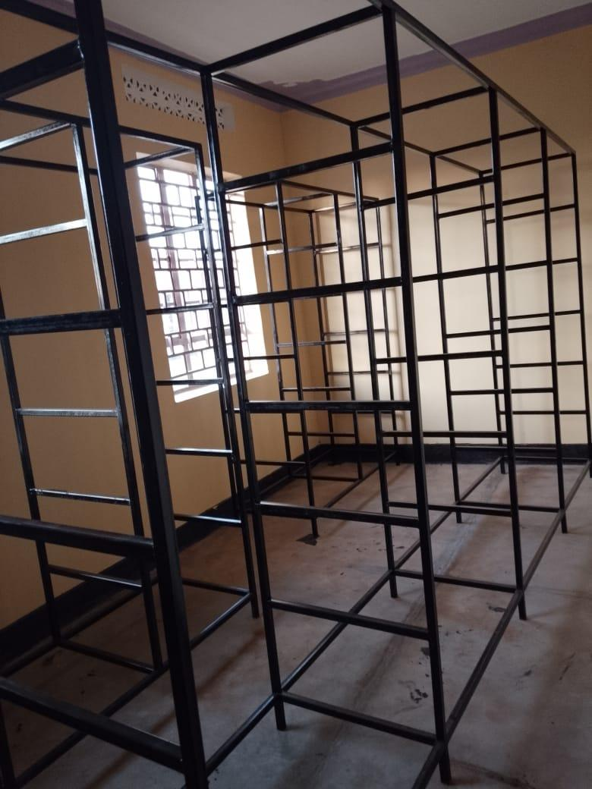
INTERIOR OF THE SCIENCE LABORATORY | 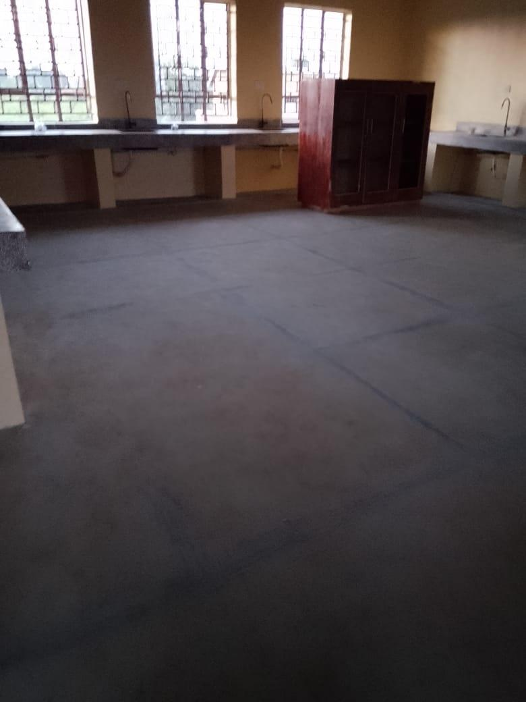
PA SYSTEM | 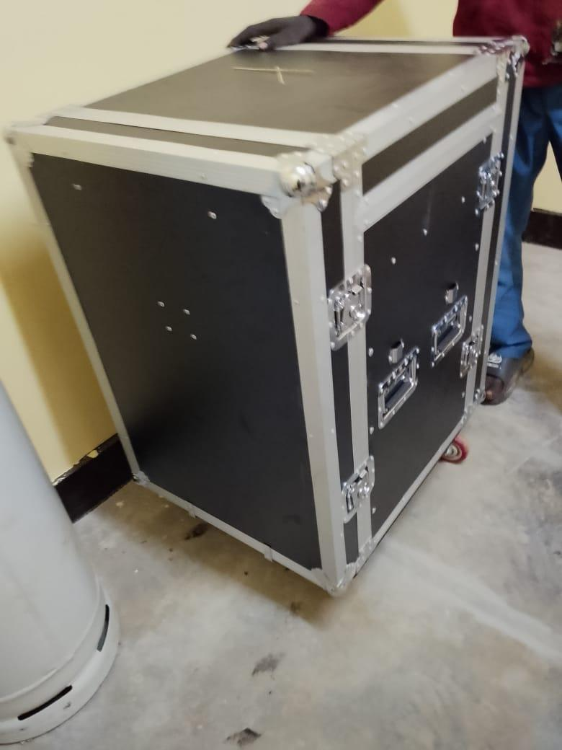
PROJECTOR | 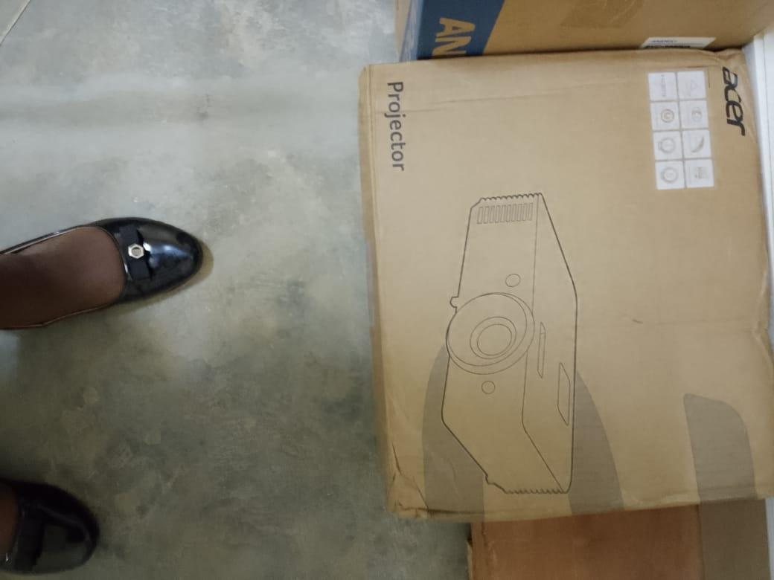
WIRE HOSE WITH 45KG GAS CYLINDER IN THE BACKGROUND | 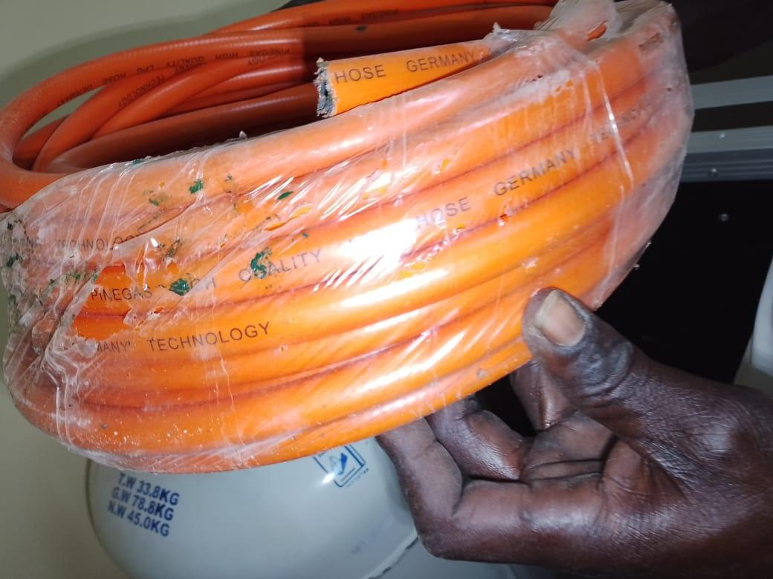
UPS | 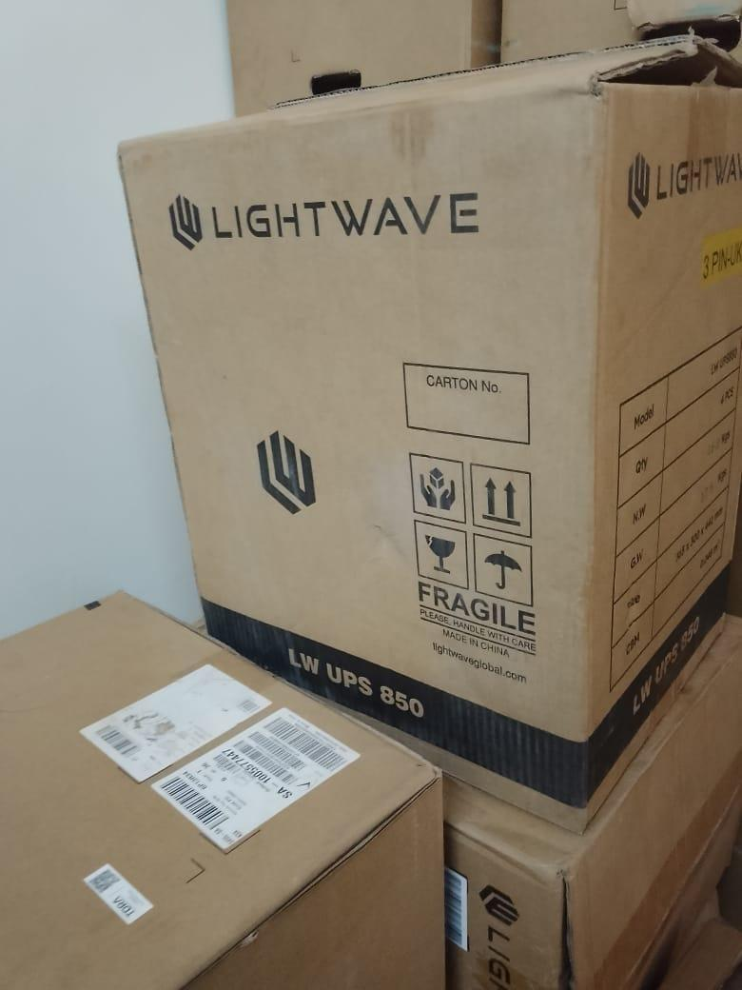
CLASSROOM DESKS | 